
QUALITY ALERT

Customer: AVANTI Date: March 4, 2025
Die: 15901 Colour: ALL
Type of Complaint: Dimension off

Q.A # Q.I.R # CUSTOMER NCR #

Description: Customer COMPLAINED dimension 0.425 run up to 0.455, not fit in the punch.
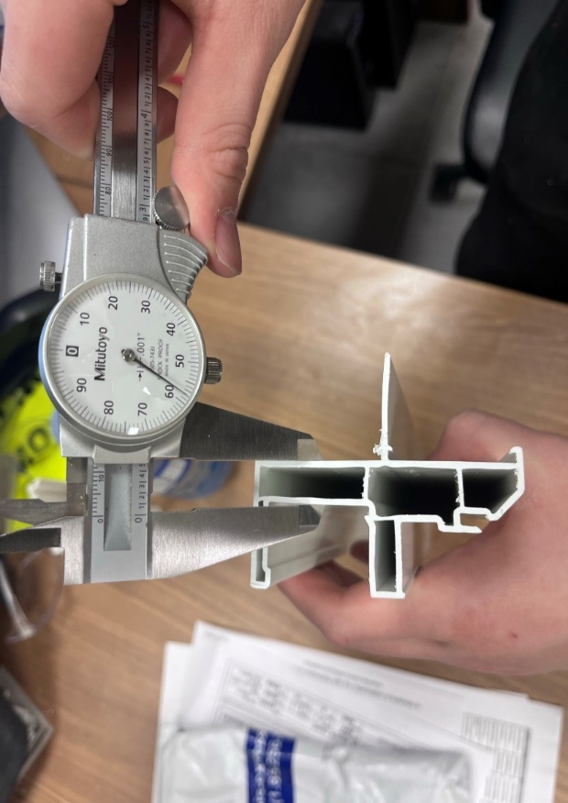
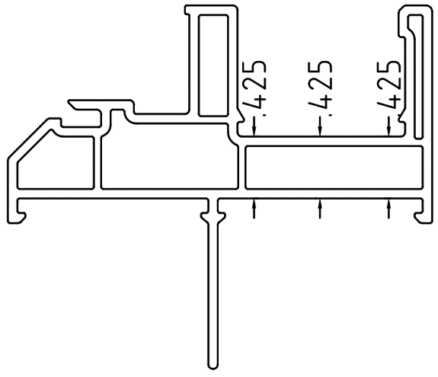

PLEASE MAKE SURE THE ABOVE DIMENSIONS IN TOLERANCE
MAXIMUM 0.440

BY SIGNING BELOW, YOU ACKNOWLEDGE THE PROBLEM ABOVE AND AGREE TO MONITOR THIS ISSUE IN FUTURE PRODUCTION RUNS.
DAY SHIFT |  | AFTERNOON SHIFT |  | NIGHT SHIFT
NAME | SIGNATURE | NAME | SIGNATURE | NAME | SIGNATURE

